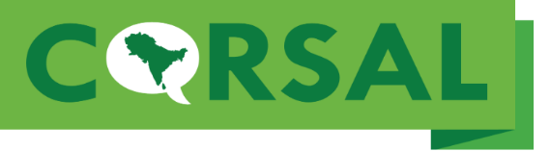
Memorandum of Agreement for Digital Rights
I/we, , affirm that I/we own the property described on this paper or attached inventory, and unconditionally give the University of North Texas (UNT) and its successors permission to digitize, host and publish online, the following items in perpetuity:
- Click or tap here to enter text.
- Click or tap here to enter text.
- Click or tap here to enter text.
I/we understand that materials hosted by the Computational Resource for South Asian Languages (CoRSAL) Archive are freely accessible for use in research, teaching (including distribution to classes), and private study. For these uses people may reproduce materials (print, make copies, or download) from CoRSAL without prior permission, on the condition that they properly cite and attribute the source of materials on all copies.
I/we understand that reproduction of CoRSAL materials for publication, broadcast, or commercial use requires my/our written permission, unless we have assigned these rights to the UNT Libraries.

Click or tap here to enter text.
Signed
Click or tap to enter a date.
Date
Address Click or tap here to enter text.
Phone Click or tap here to enter text.

